Dis-ME-Bactria-Margiana-seated female figure-14 x 10 cm

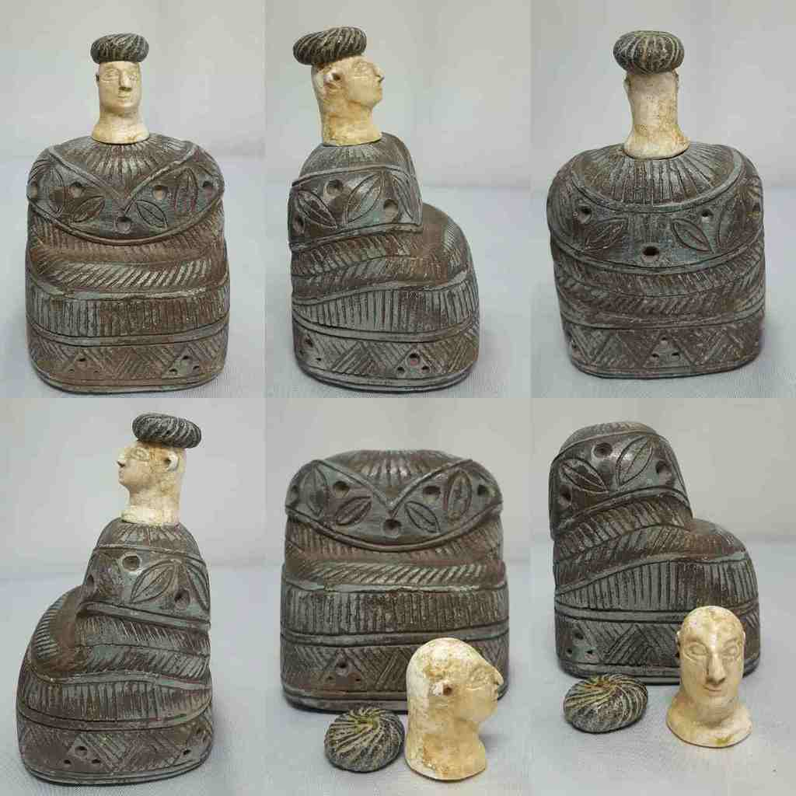

Formal Label: Bactria-Margiana composite chlorite and white calcite seated female with chlorite cap, Middle to Late Bronze Age, 2000-1650 BCE

Accession Number: GN778.32.A4

Display

Date or Time Horizon: Middle to Late Bronze Age, 2000-1650 BCE

Geographical Area: Afghanistan

Cultural Affiliation: BMAC (Oxus)

Media: composite chlorite body and cap and white calcite head

Dimensions: H 14 cm x W 10 cm

Weight:

Provenance: [vintage.intaglio](http://myworld.ebay.com/vintage.intaglio), Thailand

**Discussion:**

**This type of statuette, which can be separated into green chlorite for the base and hat and whte alabaster or marble for the head, originated with the Oxus civilization now known as the Bartrian-Margiana Oxus Civilization, which occupies in Central Asia the territories of Bactria, to the east, and Margiana, to the west.**

**The biggest volume of the room is occupied by a very large dress with puffed sleeves, covered from the waist by a gown which accentuates its amplitude; The two parts of the garment are of a woolly material stylized in superposed tabs, which is obviously inspired by the Sumerian kaunakes, skirt with long hair arranged in scales. A rigid headgear with a tip at the back encloses all the hair and makes it difficult to distinguish between the two.**

**The manufacture obeys very precise canons: head and costume are carved in a gray steatite, while the lightest stone serves uncoved parts of the body; The module corresponding to the face and neck extended by a decollete begins to fit exactly into the neckline of the garment. The arms and hands, now lost, were lodged in the mortises at the end of the sleeves and resting on the small platform formed at the front at the waist.**

**The "princesses of Bactria" eventually represented ladies of the aristocracy, perhaps even deified, but most often they personified the first-rate goddess who in the mythology of Central Asia plays a regulatory role in the the order of nature, pacifying the wild forces incarnated by lions, serpents or dragons. It is very identifiable in the glyptic, its identity is more controversial in the statuary**

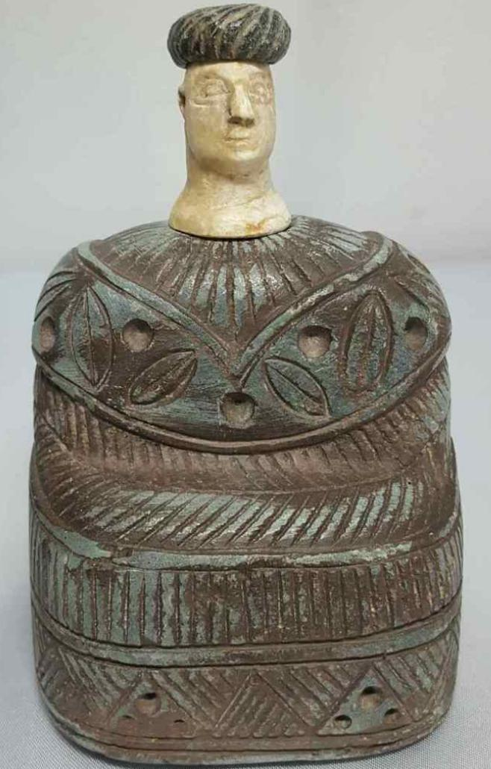

Sold by [vintage.intaglio](http://myworld.ebay.com/vintage.intaglio) ( [457](http://feedback.ebay.com/ws/eBayISAPI.dll?ViewFeedback&userid=vintage.intaglio) )

Estimated delivery Tuesday, Dec 27, 2016 - Wednesday, Jan 11, 2017

#### [Old Bactrian composite stone seated female figure idol Statue # M](http://www.ebay.com/itm/282284524718)

|  |  |
| --- | --- |
| Item price | $560.00 |
| Quantity | 1 |
| Item number | 282284524718 |
| Shipping service | Economy Shipping from outside US |

## Shipping address

Ralph J Coffman Jr

149 Atlantic Ave

Swampscott MA 01907-2427

United States

## Order total

|  |  |
| --- | --- |
| Subtotal | $560.00 |
| Shipping | $5.00 |

**Total**

$565.00